## **Question & Answers- Rectifiers**

**ECE 100 – Basic Electronics Engineering**

**PART-A**

[12 marks× 4 questions]

*(Numerical, derivations, descriptions and concepts/ Answer expected to be within one or two pages only/Direct questions, expected all students to attend without any difficulty/Maximum of two Subdivisions/Subdivisions must be labeled only as (a) and (b), 4 numbers of 12 marks questions, DOD 1)*

1. **(a)** **Half Wave Rectifier – Working**

Explain the working of a half wave rectifier using circuit diagram and waveform for positive and negative half cycles (6)

SOLUTION:

|  |  |  |
| --- | --- | --- |
|  | + ve Half Cycle | -ve Half Cycle |
| Time | 0<t<T/2 | T/2<t<T |
| Source voltage polarity | + ve | -ve |
| Circuit  Diagram |  |  |
| Modified  Circuit  Diagram  (Diode as a closed switch) |  |  |
| Output Voltage  waveform |  |  |
| Output Voltage | Same as source voltage | zero |

**(b) Half Wave Rectifier – To find output power peak & average values**

Determine the peak and average power delivered to RL. (6)

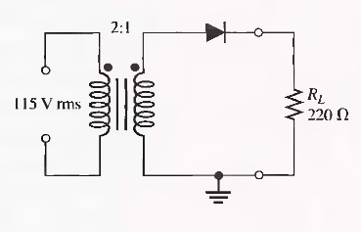

SOLUTION:

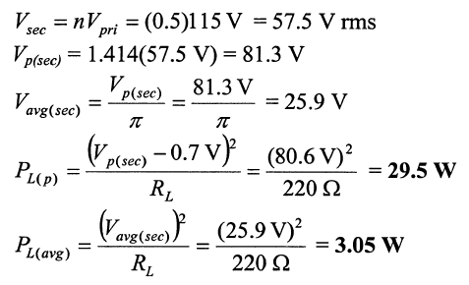

1. **(a)** **Full Wave Rectifier – Working**

Explain the working of a full wave rectifier using circuit diagram and waveform for positive and negative half cycles (6)

SOLUTION:

|  |  |  |
| --- | --- | --- |
|  | + ve Half Cycle | -ve Half Cycle |
| Time | 0<t<T/2 | T/2<t<T |
| Source voltage |  |  |
| Source voltage polarity | + ve | -ve |
| Circuit  Diagram |  |  |
| Modified  Circuit  Diagram  (Diode as a closed switch) |  |  |
| Output Voltage  waveform |  |  |
| Output Voltage | Same as source voltage | - (source voltage) |

**(b)** **Rectifier – to sketch output Voltage**

Sketch vo for the network of Fig. below and determine the dc voltage available.(6)



SOLUTION:

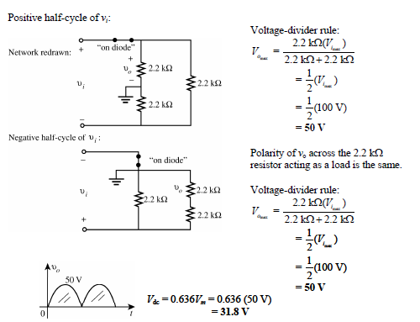

1. **(a)** **Half wave Rectifier – Output Voltage & PIV Derivation**

Derive the equation for average value of output voltage & PIV for a half wave rectifier using ideal diode (6)

SOLUTION:

* + Calculating Vdc (for Ideal diode)
  + The output signal *vo* now has a net positive area above the axis over a full period and an average value determined by

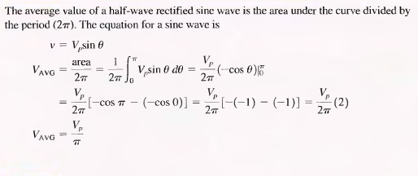

* + *V*dc = 0.318*Vm*
  + PIV = Vp

**(b)** **Rectifier – Output Voltage**

Sketch Vo for the network of Figure below and determine the dc voltage available.(6)



SOLUTION:

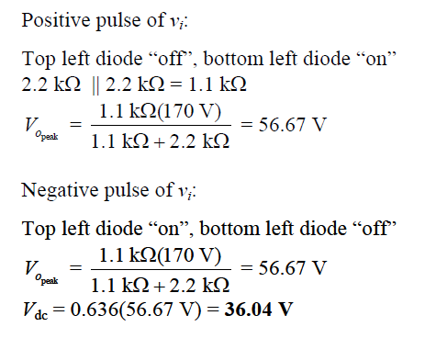

1. **(a)** **Full wave Rectifier – Output Voltage & PIV Derivation**

Derive the equation for average value of output voltage & PIV for a full wave rectifier using ideal diode (6)

SOLUTION:

* + PIV
    1. Peak inverse voltage = Vm
  + Calculating Vdc (for Ideal diode)
    1. For half wave rectifier :



* + Since the area above the axis for one full cycle is now twice that obtained for a half-wave system, the dc level has also been doubled.
  + Vdc (full wave rectifier)= 2× Vdc (half wave rectifier)
  + *V*dc = 2(0.318*Vm*)
  + *V*dc = 0.636*Vm*

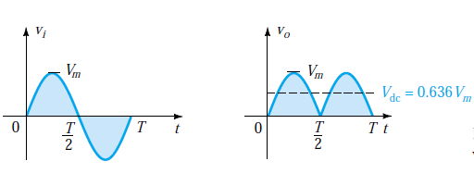

**(b)** **Rectifier – Output Voltage**

Sketch Vo for the network of Figure below and determine the dc voltage available.(6)

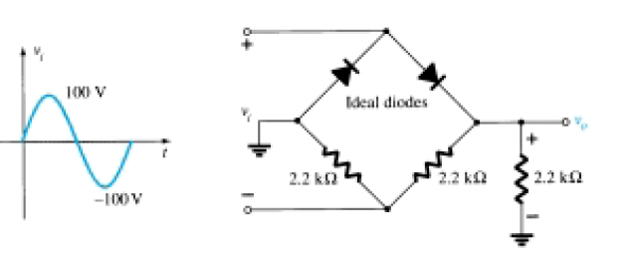

SOLUTION:

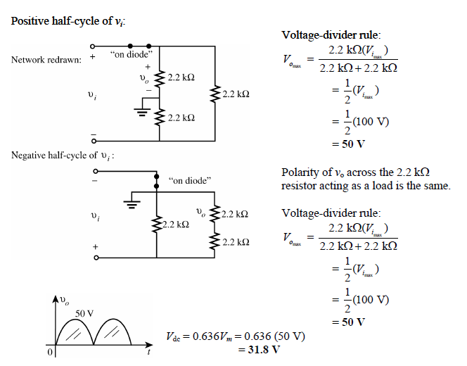

**PART-B**

[04 Marks× 3 Questions]

(Concepts and numerical/Answer expected to be within half or one page only/All above average students should attend with less difficulty/ 3 numbers of four marks questions, DOD 2)

1. **Half Wave Rectifier – To get output Waveform from Input waveform**

Draw the output voltage waveform for each circuit in Figure below and include the voltage values.

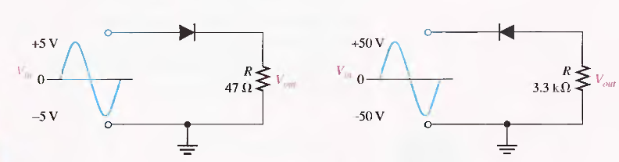

SOLUTION:

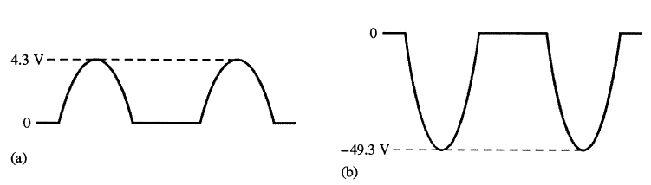

1. **Half Wave Rectifier – To get input voltage, diode voltage, diode current waveforms**

Assuming an ideal diode, sketch *vi*, *vd*, and *id* for the half-wave rectifier of Fig below. The input is a sinusoidal waveform with a frequency of 50 Hz

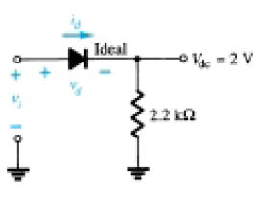

SOLUTION:

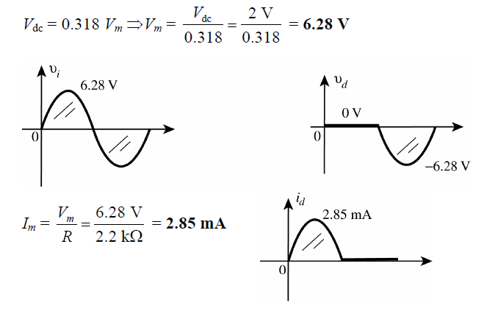

1. **Bridge rectifier with transformer- to find PIV**

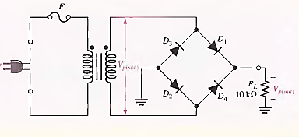Determine the peak output voltage for the bridge rectifier in Figure below. Assuming the practical model, what PIV rating is required for the diodes? The transformer is specified to have a 12 V rms secondary voltage for the standard 110 V across the primary.

SOLUTION:

The peak output voltage (taking into account the two diode drops) is

­Vp(sec) = 1.4l4Vrms

= 1.414(12 V)

=17 V

Vp(out) = Vp(sec) - 1.4 V

= 17 V - 1.4 V

= 15.6 V

The PIV rating for each diode is

­PIV = Vp(out) + 0.7 V

= 15.6 V + 0.7 V

= 16.3 V

**PART-C**

[02 marks× 3 Questions]

*(Answer not more than single sentence or word only. Whole section (part-C) should be restricted to one page only. Answering is based on reasoning and thinking based only. 3 numbers of two mark questions. Must be in one word questions (Fill ups), DOD 3)*

1. When a 60 Hz sinusoidal voltage is applied to the input of a full-wave rectifier. The output frequency is _________________.

­ (a) 120 Hz

(b) 60 Hz

(c) 240 Hz

(d) 0 Hz

SOLUTION:

* 1. **120 Hz**

1. The peak value of the input to a half-wave rectifier is 10 V. The approximate peak value of the output is _____________________.

­ (a) 10 V

­ (b) 3.18V

­ (c) 10.7 V

­ (d) 9.3 V

SOLUTION:

**(d) 9.3 V**

1. When the rms output voltage of a bridge full-wave rectifier is­ 20 V. the peak inverse voltage across the diodes is (neglecting the diode drop) ___________________.

(a) 20 V

(b) 40 V

(c) 28.3 V

(d) 56.6 V

SOLUTION:

**(c) 28.3 V**

**Extra Questions:**

1. V0 for the circuit below =__________

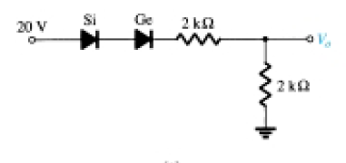

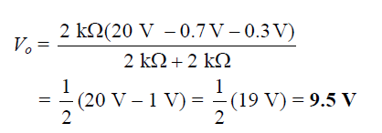

1. V0 for the circuit below =__________

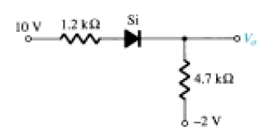

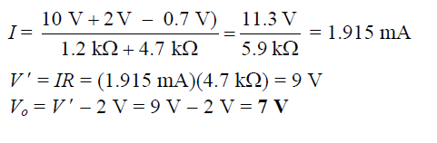

1. Vo1 and Vo2 for the networks of Fig below are ___ and _____

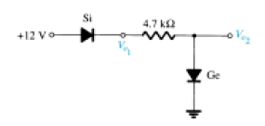



1. **Half Wave Rectifier – to sketch output voltage waveform**

For the network of Fig., sketch *vo* and determine *V*dc.



SOLUTION:



